Alexander N. Chin

Professor Mazidi

CS 2340.00

8 April 2022

Bitmap Project Report

Instructions on how to run the program:

1. place all files in the same folder

3. Run Mars and open main.asm

2. Assemble and run the program

3. Connect the bitmap (inside tools tab)

4. Set unit width and height to 4x4

5. Set display width and height to 1024x512

6. Connect the keyboard (inside tools tab)

7. Type into the keyboard simulator to play visualizations

8. keys '1' through '4' to play their associated sorting algorithm

9. Press '0' to exit the program

Overview:

The purpose of this program is to give a visual representation of a few popular sorting algorithms to use as a teaching resource for greater understanding of each algorithm. The program first generates a list of columns with randomized height that are displayed with colors corresponding to their height. The program then animates this list being sorted by the corresponding sorting algorithm depending on the user input. At the end of the sort, the program sweeps through each column and plays a sound with a pitch that is proportional to the height of the current column. The program ends when the user inputs a ‘0’.

Flowchart:

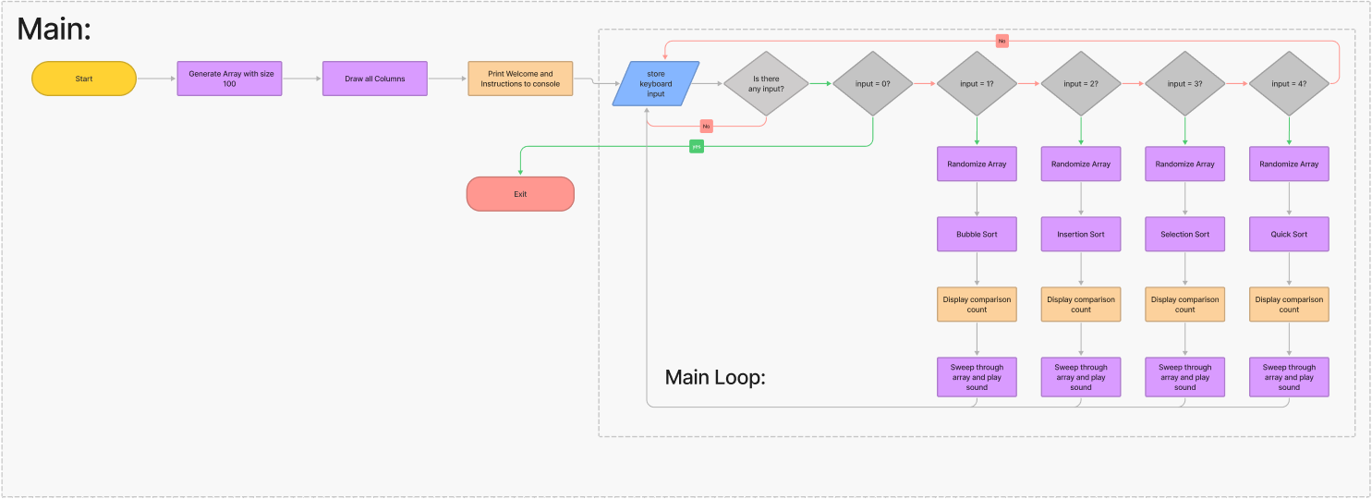

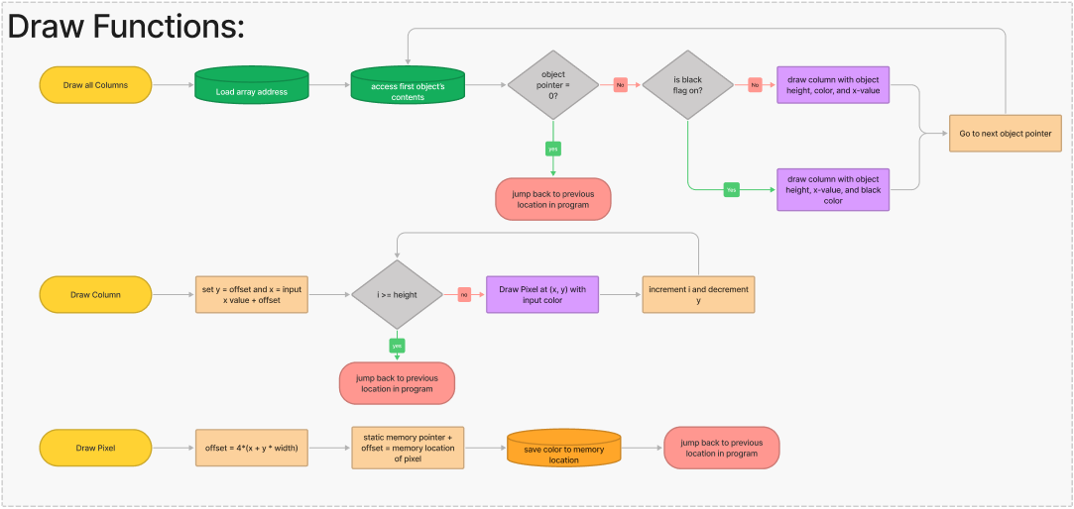

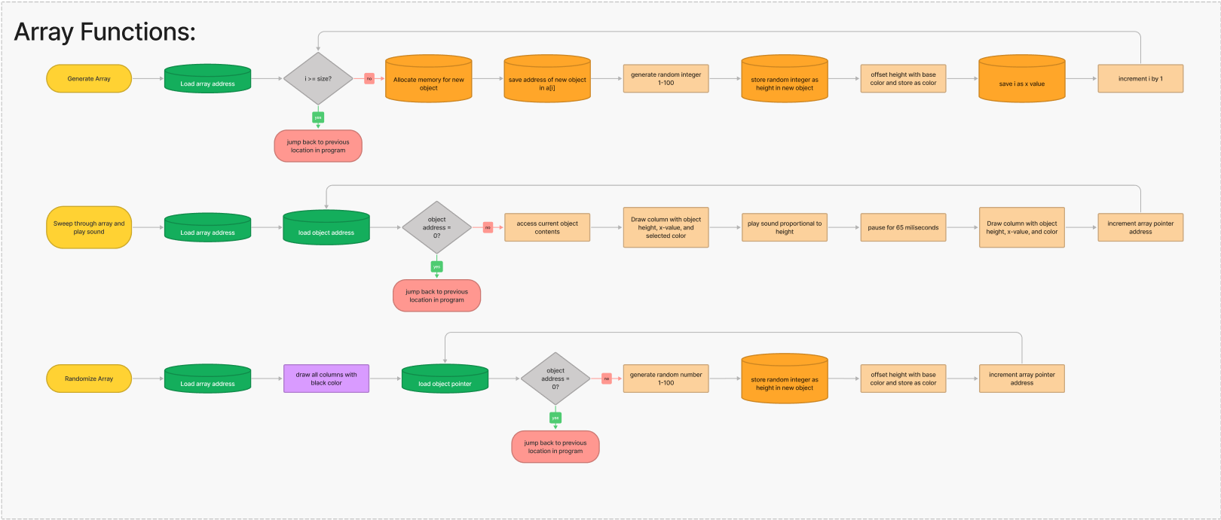

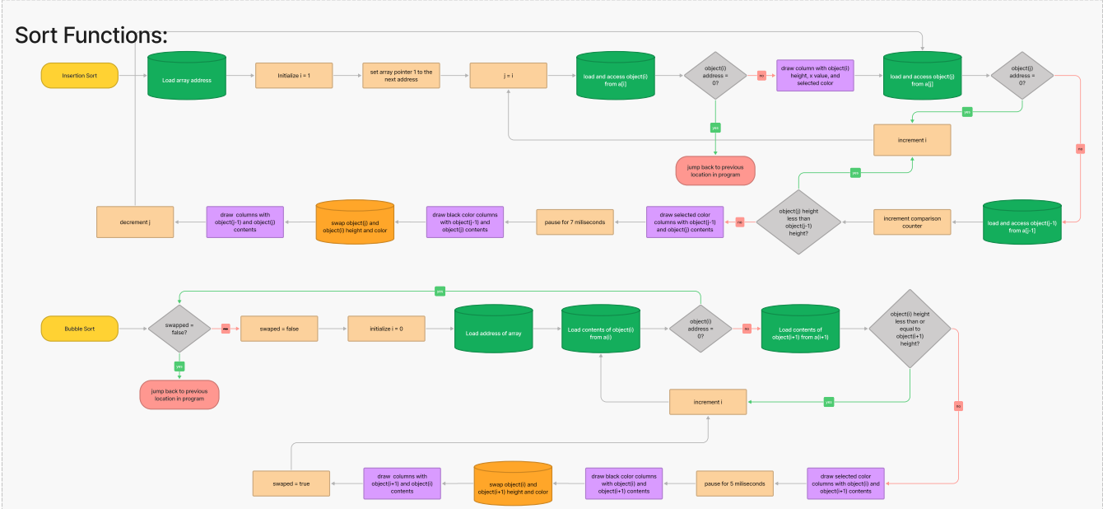

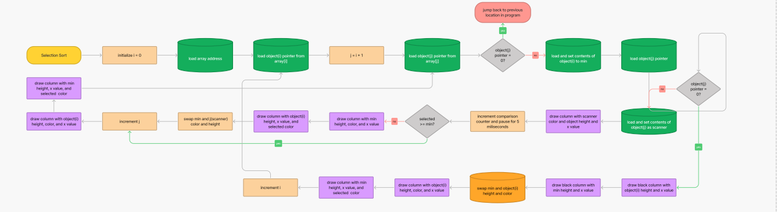

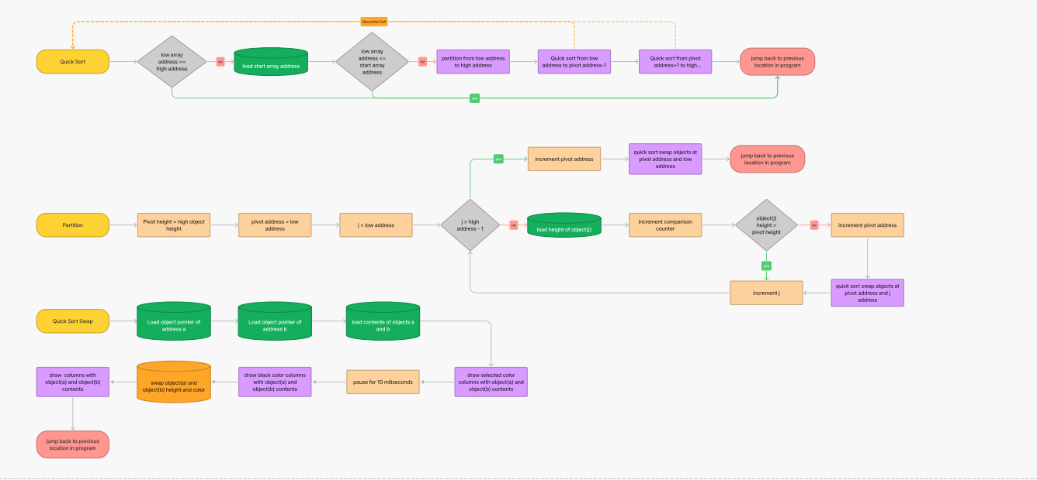

Use link below or open pdf to access full flowchart

<https://www.figma.com/file/NjuWGJoBs5kXJXKhUUq44O/Sorting-Visualizer-Flowchart>

Screenshots/GIFs of sample runs:

Quicksort:



Selection Sort:



Insertion sort: 

Bubble sort: 

Comparisons display:

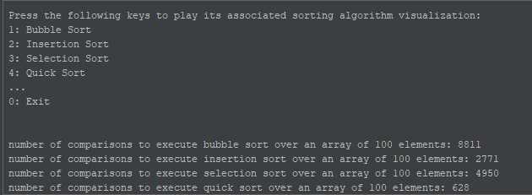

Warnings:

This program is very resource heavy, so make sure to close background processes to increase performance. Do not input keys too quickly into the keyboard or it will lock up Mars.

GITHub Link:

<https://github.com/Alexander-N-Chin/Sorting-Visualizer>